Poetic Dialogues
Sandra Buechler
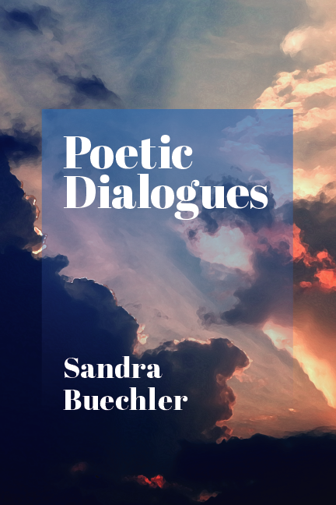

http://ipbooks.net/product/poetic-dialogues-by-Sandra-Buechler

Description
Some poems inspire me, some move me, some make me feel found. Sometimes reading a poem tells me what I already knew, but had never thought. Poems live at the crossroads between thought and feeling, poet and reader.
Writing Poetic Dialogues was a leap of faith. I trusted my own associative process. I believed that if I put lines from an evocative Mary Oliver poem next to lines I love from Emily Dickinson, I might hear both poems differently. Meaning is often born in dialogue.
When anyone has asked me how to learn the art of psychoanalytic interpretation, I have always suggested that they read poetry. Both arts rely on the economical use of words. Both aim for radical truthfulness. They know they must be honest. Both communicate on many levels at once, which enhances their impact. Their meaning is conveyed by their form, as well as their content. The best interpretations, like poems, have dimensionality, or “legs.” They have the power to take us somewhere new.
Poems have always helped me balance my feelings. Some have lent me hope or inspired resilience. Some have made me feel less lonely, by demonstrating that another human being, the poet, must have felt something like what I feel, since their poem so accurately mirrors my experience. Sometimes a word in a poem opens me to a new understanding or surprises me with a new connection. T.S. Eliot (1943) recommended voyaging inward as we grow older. Some poems, like powerful interpretations, take me on new voyages.
Poetry, like psychoanalysis, deals with big subjects-time, loss, death, beauty, childhood, nature, and the good life, among others. Poems are not afraid of mystery. They let meaning happen slowly. They leaven sorrow and foster wonder. Like good interpretations, some poems introduce us to the stranger within ourselves.
When I listen to Lucille Clifton’s “shapeshifter” poems, (about being sexually abused by her father) I also hear Linda McCarriston’s (1995) heart-rending memories. Each amplifies the power of the other, but, together, they also bring the consolation of human connection.

References
Clifton, L. (2020), Shapeshifter poems. In: How to Carry Water: Selected Poems. Rochester, N.Y.: BOA Editions.
Eliot, T.S. (1943), East Coker. In: Four Quartets. New York: Harcourt.
McCarriston, L.A. (1995), A castle in Lynn. In: The Language of Life: A Festival of Poets, Ed.: B. Moyers. New York: Anchor Books.

